**Software Requirements Specification**

**Version 2.0**

**Trip Manager**

**Team 4**

|  |  |  |
| --- | --- | --- |
| **Member Name** | **Member Roll #** | **Primary Responsibility** |
| **Umair Zohaib** | **15L-4247** | **Overall Description** |
| **Hamza Rashid** | **15L-4280** | **E-R Diagram + Component Diagram** |
| **Umer Riaz** | **15L-4152** | **Analysis Class Diagram + Use Cases** |
| **Hassan Saleem** | **15L-4330** | **DFD Diagram** |

**Table of Contents**

**Table of Contents 3**

**Revision History 4**

**1.** **Introduction 5**

1.1 Product 5

1.2 Scope 5

1.3 Business Goals 5

1.4 Document Conventions 5

1.5 References 6

**2.** **Overall Description 6**

2.1 Product Features 6

2.2 User Classes and Characteristics 6

2.3 Operating Environment 7

2.4 Design and Implementation Constraints 7

2.5 Assumptions and Dependencies 7

**3.** **Functional Requirements 8**

3.1 Use-Case 1 8

3.2 Use-Case 2 9

3.3 Use-Case3 10

3.4 Use-Case4 11

3.5 Use-Case5 12

3.6 Use-Case6 13

3.7 Use-Case7 14

**4.** **Nonfunctional Requirements** 15

4.1 Security Requirements 15

**5.** **Other Requirements** 15

**Appendix A: Glossary** 16

**Appendix B: Analysis Models** 17

**Appendix C: Design Models 22**

**Revision History**

|  |  |  |  |
| --- | --- | --- | --- |
| **Name(s)** | **Date** | **Reason(s) For Change(s)** | **Version** |
| Hassan Saleem |  | Added DFD Diagram |  |
| Hamza Rashid |  | Added E-R diagram |  |
| Umer Riaz |  | Made Corrections in the Use Case description and Added Analysis Class Diagram |  |

# **1. Introduction**

# **1.1 Product**

## A web-based solution to help automate travel authorization and manage travel expenses of employees. This product is helpful for the company to setting the employees and their corresponding expenses for the tour from the company. This can make an ease for the higher hierarchy of the company to review the expenses data of a specific employee for some specific tour.

## **1.2 Scope**

Employees will be able to ask for authorization of their trips by filling an application. HR manager will be able to approve or disapprove these application.

Employees will be adding their expenses during the trip and upload payment slips as proof.

HR manager will be able to approve of these expenses and then the employee can claim their money back.

All these travel expenses will be recorded in a DB so that a senior manager can view a report of all the expenses made by employees and apply filters to these reports.

## **1.3 Business Goals**

The product will help make the travel management easy for the company and will also be able to keep proper record of expenses made by employees. Getting trips approved will be more convenient for employees which is also in company’s benefit.

## **1.4 Document Conventions**

* SM stands for Senior Manager.
* DB stands for Database.
* Citation format is APA.
* All heading are in bold.

## **1.5 References**

1. Bandakkanavar, R. (2018). Software Requirements Specification document with example - Krazytech. Retrieved from <https://krazytech.com/projects/sample-software-requirements-specificationsrs-report-airline-database>

2. How to write an SRS document retrieved from <https://www.bmc.com/blogs/software-requirements-specification-how-to-write-srs-with-examples/>

3. SRS document template retrieved from https://xbsoftware.com/free-srs-template/

# **2. Overall Description**

## **2.1 Product Features**

User will sign up as a traveler. Then after logging in he will be able to view his current trips or ask for authorization of a new trip by filling the travel authorization application form. He will also be able to add expenses to his current trip and upload a slip as proof. He can then end the trip.

After logging in user, will able to view all applications and approve or disapprove them. User will also be able to approve or disapprove expenses made by the employees.

Senior Manager will be able to view reports of employee’s expenses and will be able to apply filters like year, month, expense amount, number of employees, employee type.

## **2.2 User Classes and Characteristics**

**Traveler**

User will sign up as an employee. Then after logging in he will be able to view his current trips or ask for authorization of a new trip by filling the travel authorization application form. He will also be able to add expenses to his current trip and upload a slip as proof. He can then end the trip.

**HR Manager**

After logging in user, will able to view all applications and approve or disapprove them. User will also be able to approve or disapprove expenses made by the employees.

**Senior Manager**

Senior Manager will be able to view reports of employee’s expenses and will be able to apply filters like year, month, expense amount, number of employees and employee type.

Most important user is HR manager. His frequency of use will be the most and thus interface needs to be user friendly for him.

## **2.3 Operating Environment**

**Hardware requirements**: A working PC, laptop, mobile or tablet and a working internet.

**Software Environment:** Google chrome version 2.0 and above will support our website. Mozilla Firefox version 3.5 and above will support.

## **2.4 Design and Implementation Constraints**

**Interfaces to other Applications:** Excel must be used to generate reports.

**Language and Communication Protocols:** No language and communication protocols

**Security Considerations:** Company’s data is very valuable. Any employee, outside person should not be able to view employee’s expenses data or application data. Employees should only be able to view their own expenses and trips.

**Design Conventions:** The solution does not need to be fancy with an attractive UI. It should be kept simple and easy to use.

**Programming Standards:** .Net was framework the client is comfortable with as it will be easy for them to maintain or in future integrate it with their current system. Client has asked for an object-oriented way of development.

## **2.5 Assumptions and Dependencies**

There are not a lot of assumed factors. The solution is web-based solution and is going to be working on the internet and not in a stand-alone environment and internet availability is not something can be doubted therefore there are no major factor that can affect the product’s working in the future.The development framework is ASP.NET, which is a very safe choice and is not expected to cause any problems in the future.

# **3. Functional Requirements**

3.1

|  |  |  |  |
| --- | --- | --- | --- |
| **Name** | | Sign Up in the application | |
| **Purpose** | | Employee can add expenses of travel after signing in | |
| **Priority** | | High | |
| **Actors** | | Employee | |
| **Pre-conditions** | | Sign up page opened | |
| **Post-conditions** | | Opens home page | |
| **Typical Course of Action** | | | |
| **S#** | **Actor Action** | | **System Response** |
| **1** | Employee will press the sign-up option | |  |
| **2** |  | | System will open the sign-up page |
| **3** | Employee will enter the username, id and password | |  |
| **4** |  | | System will check the entered details |
| **5** | Employee clicks the submit button | |  |
| **6** |  | | System will login the user in application. |
| **Alternate Course of Action** | | | |
| **S#** | **Actor Action** | | **System Response** |
| **4** | User already have account | |  |
|  |  | | System displays account already exists |
| **…** |  | |  |

## **3.2**

|  |  |  |  |
| --- | --- | --- | --- |
| **Name** | | Login | |
| **Purpose** | | Log into the system | |
| **Priority** | | High | |
| **Actors** | | Traveler, Hr Manager, Senior manager | |
| **Pre-conditions** | | User has an account | |
| **Post-conditions** | | User will be logged in to his/her account | |
| **Typical Course of Action** | | | |
| **S#** | **Actor Action** | | **System Response** |
| **1** | User clicks on application to open | |  |
| **2** |  | | System will start application |
| **3** | User will press the select user type | |  |
| **4** | User will enter the username/employee code and password | |  |
| **5** |  | | System checks the credentials |
| **6** |  | | System will login the user |
| **Alternate Course of Action** | | | |
| **S#** | **Actor Action** | | **System Response** |
| **6** | User enters wrong credentials | |  |
| **7** |  | | System will inform the user about wrong credential. |

**3.3**

|  |  |  |  |
| --- | --- | --- | --- |
| **Name** | | Fill form for trip authorization | |
| **Purpose** | | Send application to HR manager | |
| **Priority** | | High | |
| **Actors** | | Employee | |
| **Pre-conditions** | | Employee is logged, Employee is not currently on a trip | |
| **Post-conditions** | | Employee will have to close trip after completing trip | |
| **Typical Course of Action** | | | |
| **S#** | **Actor Action** | | **System Response** |
| **1** | Employee clicks on the form for trip | |  |
| **2** |  | | System will open the form details |
| **3** | Employee will provide the his/her user name and password | |  |
| **4** |  | | System will check in DB for entered credentials |
| **5** | Employee then provides the trip information | |  |
| **6** |  | | System will save the info |
| **7** | Employee clicks the submit button | |  |
|  |  | | System will add the trip for employee |
| **Alternate Course of Action** | | | |
| **S#** | **Actor Action** | | **System Response** |
| **4** | User filled the form incorrectly | |  |
| **5** |  | | System shows a message to correct the form |
| **6** | User corrects the mistakes on the form and submits is again | |  |
| **7** |  | | System shows a confirmation to the user about form submission |
| **…** |  | |  |

## **3.4**

|  |  |  |  |
| --- | --- | --- | --- |
| **Name** | | Approve trip | |
| **Purpose** | | Approve or disapprove trips requested by travelers | |
| **Priority** | | High | |
| **Actors** | | HR Manager | |
| **Pre-conditions** | | There are trips waiting to be approved/disapproved, HR manager is logged in | |
| **Post-conditions** | | Trip’s status gets updated | |
| **Typical Course of Action** | | | |
| **S#** | **Actor Action** | | **System Response** |
| **1** | HR Manager clicks the view waiting trips button | |  |
| **2** |  | | System shows a list of trips. |
| **3** | HR Manager clicks on of the trips. | |  |
| **4** |  | | System shows details of the trip |
| **5** | HR manager approves the trip | |  |
| **6** |  | | System updates the status of trip |
| **Alternate Course of Action** | | | |
| **5** | HR manager disapproves the trip | |  |
|  |  | | System updates the status of trip |

**3.5**

|  |  |  |  |
| --- | --- | --- | --- |
| **Name** | | Add Travel Expenses | |
| **Purpose** | | Employee can claim the amount spent | |
| **Priority** | | High | |
| **Actors** | | Employee | |
| **Pre-conditions** | | Employee is logged in; Employees trip is approved | |
| **Post-conditions** | | Travel Expenses added | |
| **Typical Course of Action** | | | |
| **S#** | **Actor Action** | | **System Response** |
| **1** | Employee clicks to opens his/her account | |  |
| **2** |  | | System will show the account page |
| **3** | User selects the add travel expense option | |  |
| **4** |  | | System asks for proof document/slip |
| **5** | User select the option to upload the slip | |  |
| **6** |  | | System asks for the location of slip |
| **7** | User selects the slip | |  |
| **8** |  | | System uploads the slip |
| **9** | User presses the submit button | |  |
| **10** |  | | System saves the slip on users account  And send it to HR Manager |
| **Alternate Course of Action** | | | |
| **S#** | **Actor Action** | | **System Response** |
| **1** |  | |  |
| **2** |  | |  |

**3.6**

|  |  |  |  |
| --- | --- | --- | --- |
| **Name** | | Approve the Travel Expenses Claim | |
| **Purpose** | | Employee can get his money back | |
| **Priority** | | Medium | |
| **Actors** | | HR Manager | |
| **Pre-conditions** | | Proof slip has submitted by employee | |
| **Post-conditions** | | Travel Expenses gets approved or disapproved | |
| **Typical Course of Action** | | | |
| **S#** | **Actor Action** | | **System Response** |
| **1** | HR Manager opens the proof slip | |  |
| **2** |  | | System shows the slip |
| **3** | Manager checks the claimed amount and approve it | |  |
| **4** |  | | System saves the slip in approved slip records and send notification to the employee |
| **Alternate Course of Action** | | | |
| **S#** | **Actor Action** | | **System Response** |
| **3** | Manager disapprove the amount claimed | |  |
| **4** |  | | System sends a message to employee |
| **5** | Manager deletes the slip | |  |
| **6** |  | | System updates the record |
| **…** |  | |  |

**3.7**

|  |  |  |  |
| --- | --- | --- | --- |
| **Name** | | View Reports | |
| **Purpose** | | SR Manager can review expenses made by employees | |
| **Priority** | | Medium | |
| **Actors** | | Senior Manager | |
| **Pre-conditions** | | Senior Manager logged in | |
| **Post-conditions** | | Senior Manager views a report | |
| **Typical Course of Action** | | | |
| **S#** | **Actor Action** | | **System Response** |
| **1** | Senior Manager selects a report | |  |
| **2** |  | | Systems shows the report |
| **3** |  | |  |
| **Alternate Course of Action** | | | |
| **S#** | **Actor Action** | | **System Response** |
| **1** |  | |  |

# **4. Nonfunctional Requirements**

## **Performance Requirements**

* System shall send application form to HR manager within 2 minutes required that HR manager is online
* Application Form for trip authorization shall require employee 5 or less minutes to be filled.

## **Security Requirements**

**Authentication**

There are three types of user; employee and HR manager will have signup and login authentication. While two senior manager accounts will be created by default.

Reports that are visible for senior manager should be protected and kept away other employees.

# **5. Other Requirements**

Database use will be MySQL database and for reuse of software there is no integration required accept the creation of senior manager accounts.

**Appendix A: Glossary**

**.NET**

ASP.NET offers three frameworks for creating web applications: [Web Forms](https://www.asp.net/get-started/websites#web-forms), [ASP.NET MVC](https://www.asp.net/get-started/websites#mvc), and [ASP.NET Web Pages](https://www.asp.net/get-started/websites#web-pages). All three frameworks are stable and mature, and you can create great web applications with any of them. No matter what framework you choose, you will get all the benefits and features of ASP.NET everywhere. NET Framework has its own security mechanism with two general features: Code Access Security (CAS), and validation and verification. CAS is based on evidence that is associated with a specific assembly. Because computer systems commonly require interaction between newer and older applications, .NET Framework provides means to access functions implemented in newer and older programs that execute outside.

**Appendix B: Analysis Models**

**Use Case Diagram:**

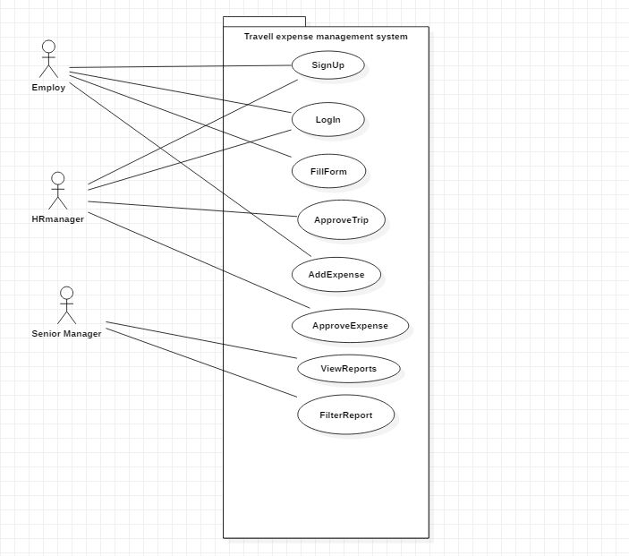

ER-Diagram:

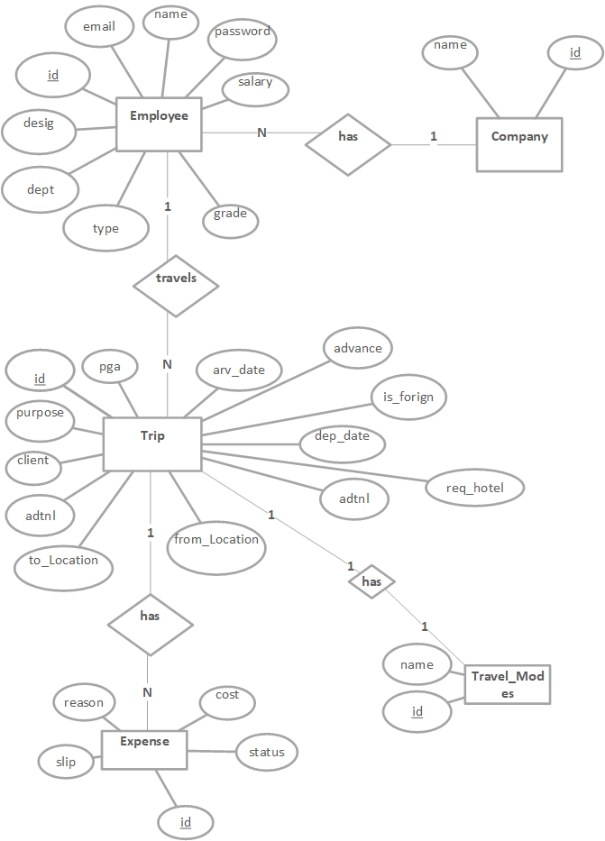

**Analysis Class Diagram**



**DFD Level 0**



**DFD Level 1:**



**Appendix C: Design Models**

**Component Diagram**

